How to Apply for the State Police Trooper Trainee Job Opening

Where do I begin?
- Locate a device (desktop, laptop, mobile smartphone, or a computer at Public Library)
- Set up an e-mail account
- Register for the State’s Online Employment Center

The State’s Website can be reached either by:
- Going to www.ct.gov and under Most Popular, click on Apply for State Job Openings

- Website: www.jobapscloud.com/ct

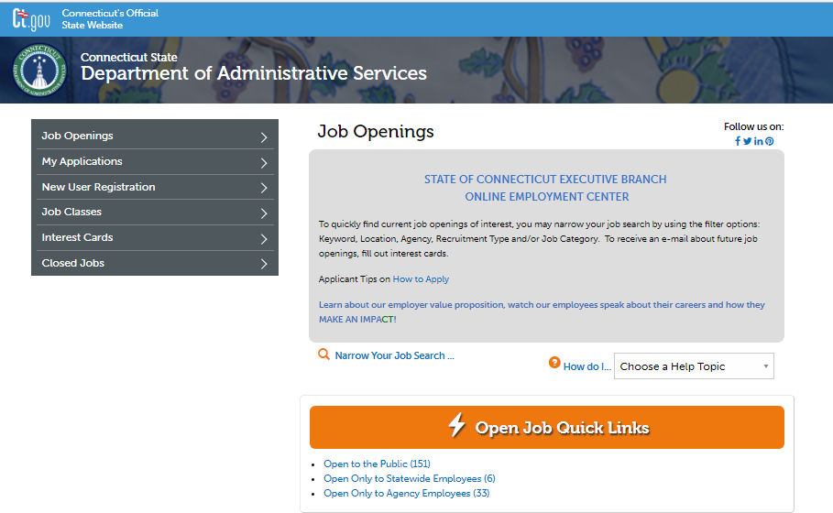
Select
New User Registration

Create a User ID (up to 10 characters) and a password (8 characters minimum; must include both letters and digits).

Important: Write down your UserID and Password for future use. User ID’s and passwords are case sensitive.

If you are having trouble registering the first time, try a different User ID as the one you are trying may already be taken.
After You Submit Your Registration:

- You’ll be on your Master Application Template screen. Once you’ve filled in and completed your Master Application Template, every time you apply for a Job Opening you can copy your Master Application Template so you do not need to retype your profile, school and work history information.
- The following sections are not copied from the Master Application Template because they vary for each position and must be filled-in with each application:
  - Profile tab > Employment Preferences
  - Resume > Ability to upload updated resume each time
  - Other tab > Any uploads required for recruitment

There are various tabs to complete of your Master Application Template:

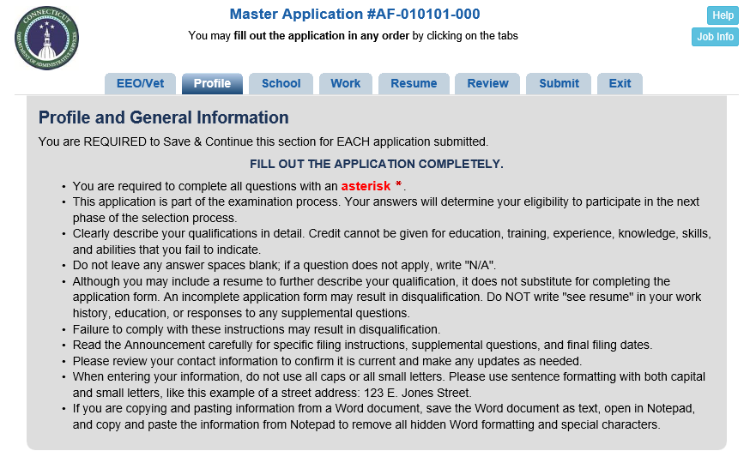

Be sure to Save & Continue at the bottom of each tab of the application. When you are ready to submit your Master Application Template, go to the Review tab to proofread, and then the Submit tab and Submit to State of CT.

You will receive both a pop-up confirmation and an e-mail confirmation after you submit your Master Application Template. Note: You have not submitted a job application, this is your master application for your entire profile. You must now apply to the specific opening.

Apply for State Police Trooper Trainee Open Position:

- Click on the Job Openings tab
- View the jobs Open to the Public
- Find the State Police Trooper Trainee recruitment and click the job title and click on Apply Online at the bottom
- The system will have you review the Terms of Agreement and then check the box and click on I have REGISTERED PREVIOUSLY
- Enter your UserID and Password, then click Retrieve Application
- At the top after logging in, the words Copy My Application will appear. Read and follow the instructions and click on your Master Application and the message Copying Application displays.
- The system creates your State Police Trooper Trainee Job #190415-7961SP-001 Application with your information started for you.
- Complete all tabs of the application and be sure to Save & Continue at the bottom of each tab.

Finalizing the Application:

- Proofread your application to ensure everything is correct.
- There is no need to sign and return a printed copy of the application – it’s your copy.
- Note: Printing a copy of your application does not constitute submission of an application.
- Important: Once you have submitted your application, you cannot make any changes to the submitted application, no exceptions.
- When you are satisfied with your application, on the Submit tab, check the Certify box which serves as your electronic signature and click Submit to State of Connecticut.
- If your application is incomplete, you will receive a pop up box stating your application HAS NOT been submitted and which tabs need reviewing.
- If the application submits successfully, you will receive a pop up confirmation in addition to a confirmation email of your application submission.

Withdrawing an Application: Important Please Read

- Never click the Withdraw button in your Personal Status Board unless you wish to be taken out of consideration for the job opening and the entire selection process. The withdraw process is permanent.
- If for any reason you withdraw your application, you cannot reapply to the same recruitment number and must wait for the next time it is posted.

What’s Next:

- On a regular basis, check your e-mail for any notices sent from the Department of Emergency Services and Public Protection about the job opening.

- A referral questionnaire will be sent out to all applicants to answer after the job opening closes.

- E-mail will be used for correspondence throughout the SPTT process. Please do not call to check on the status of your application.

- Be sure to check your junk and spam folders for e-mail correspondence! Applicants that have a @gmail.com address typically get their email notices sent to their spam folder.

Please add @ct.gov as an accepted address to any email blocking or spam filtering program you may use. Even if you do not receive any email notices, you are responsible for logging in to your Personal Status Board and reviewing all notices that have been sent to you. Under the ‘Submitted and Unfinished Applications’ area of your account, view the ‘Last Notice’ column and click on the date to see the Last Notice emailed to you.

